VIEW

CREATE VIEW VIEW_STU AS SELECT STU_ID,STU_NAME,DEPT FROM STU;

SELECT *FROM VIEW_STU;

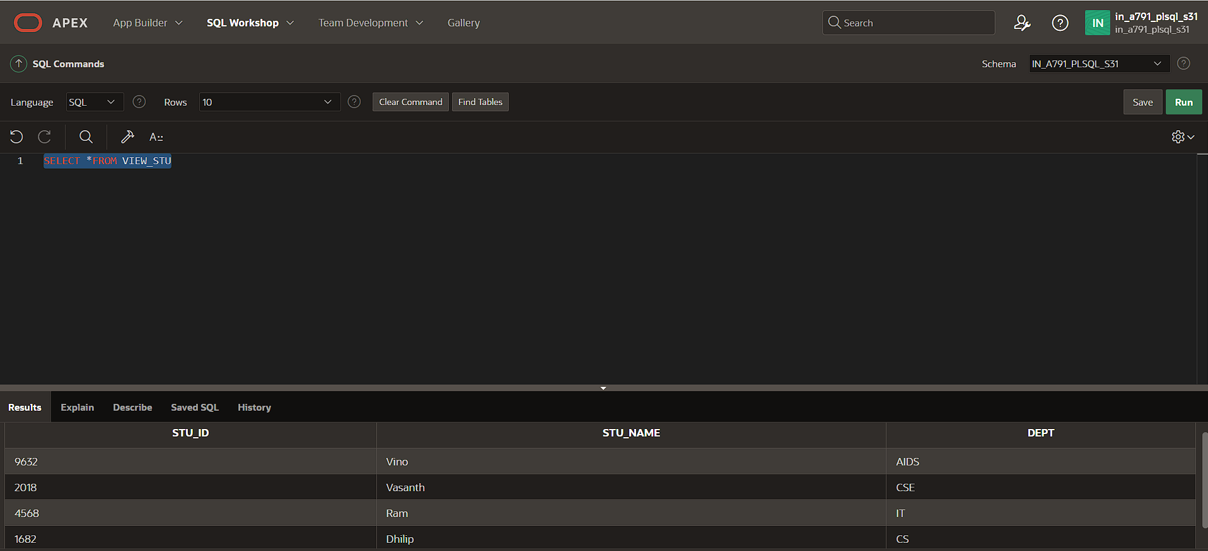

DROP VIEW VIEW_STU;

SEQUENCE

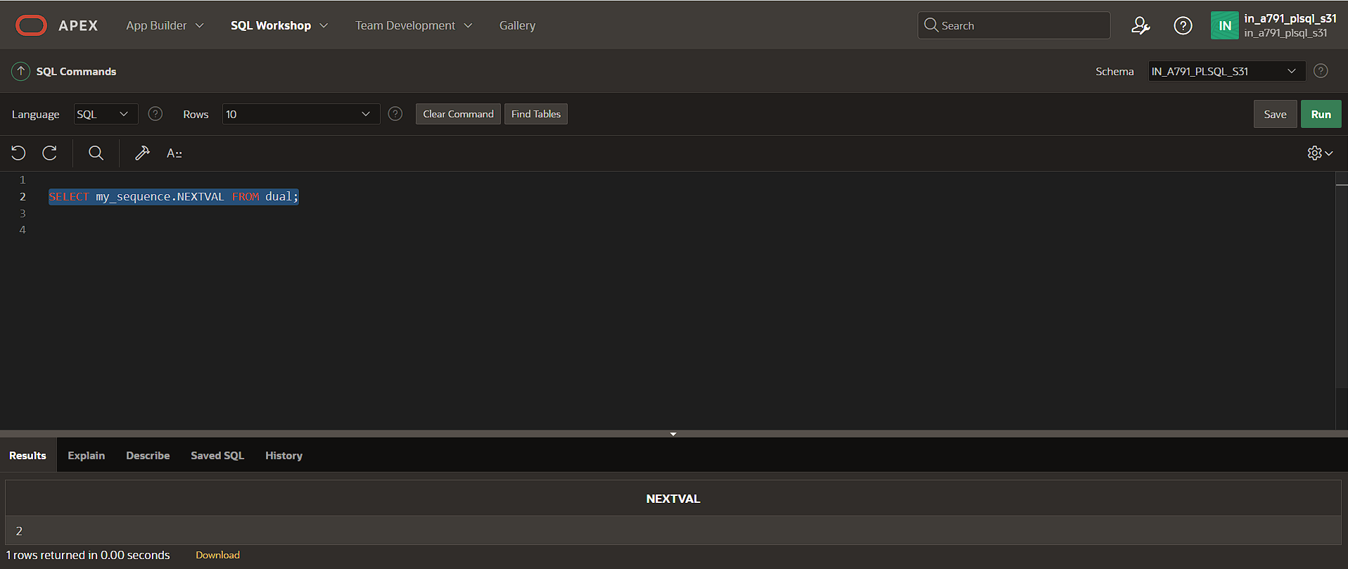

SELECT my_sequence.CURRVAL FROM dual;

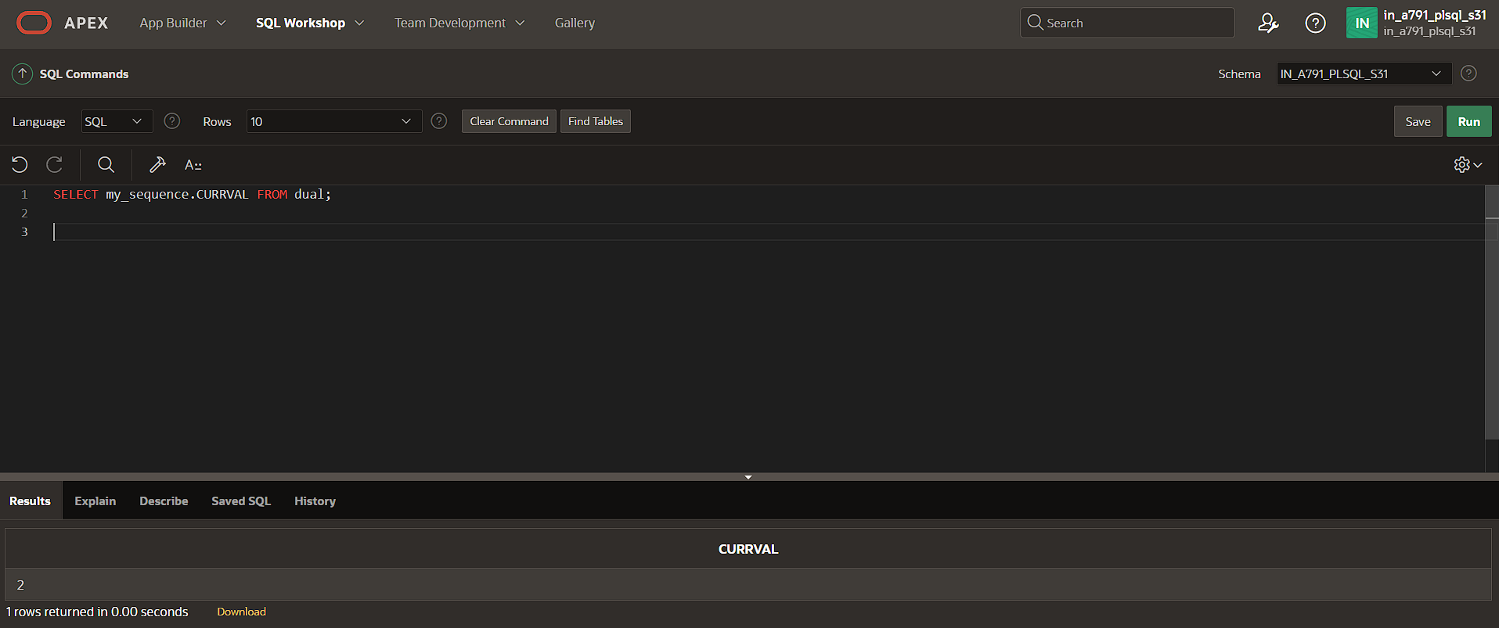

DROP SEQUENCE my_sequence;

CREATE SEQUENCE seq1 START WITH 1 INCREMENT BY 1 MINVALUE 1 MAXVALUE 3 CYCLE CACHE 2;

SELECT seq1.NEXTVAL FROM dual;

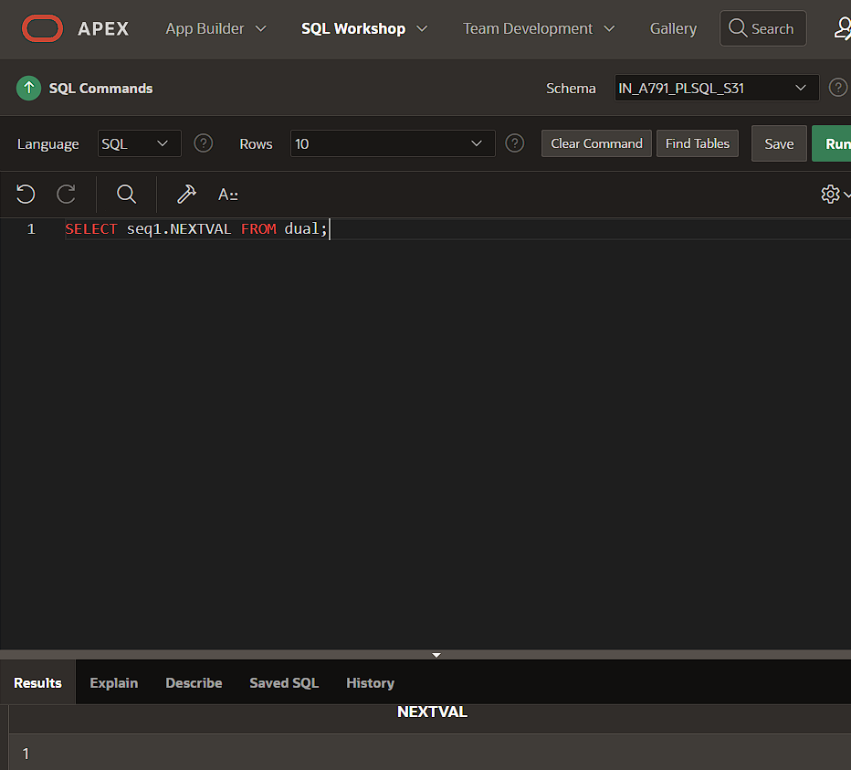

SELECT seq1.NEXTVAL FROM dual;

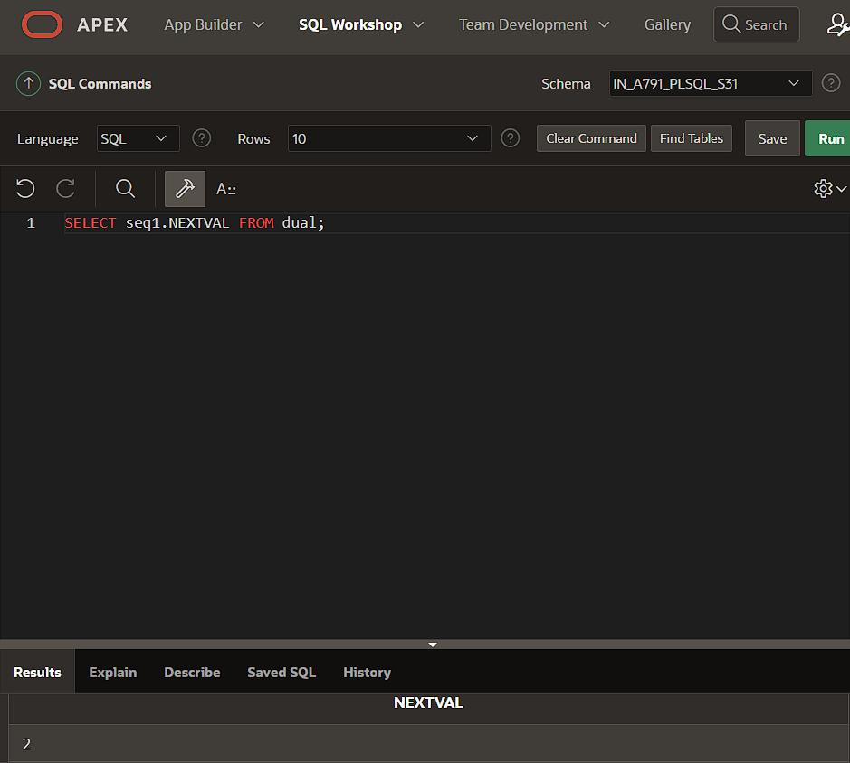

SELECT seq1.CURRVAL FROM dual;

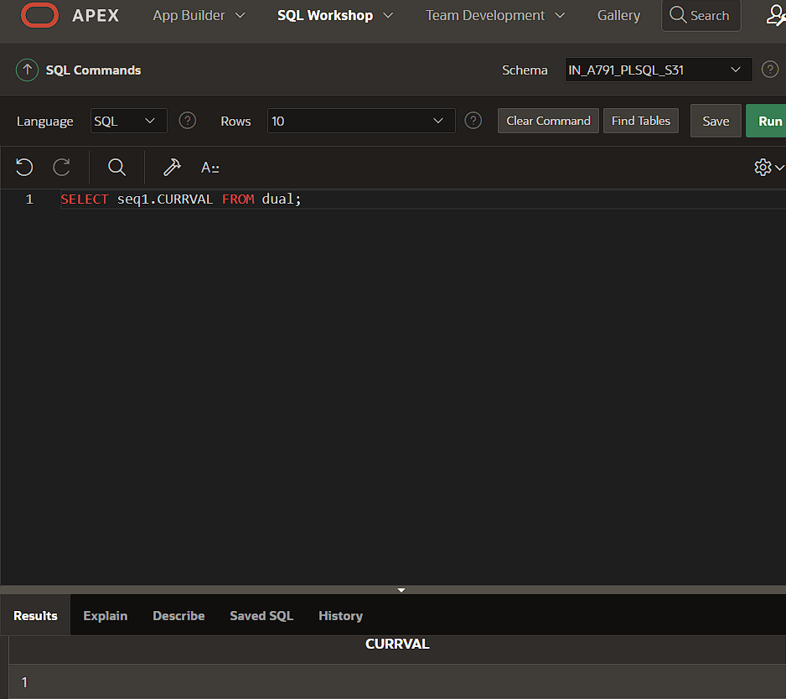

SELECT seq1.NEXTVAL FROM dual;

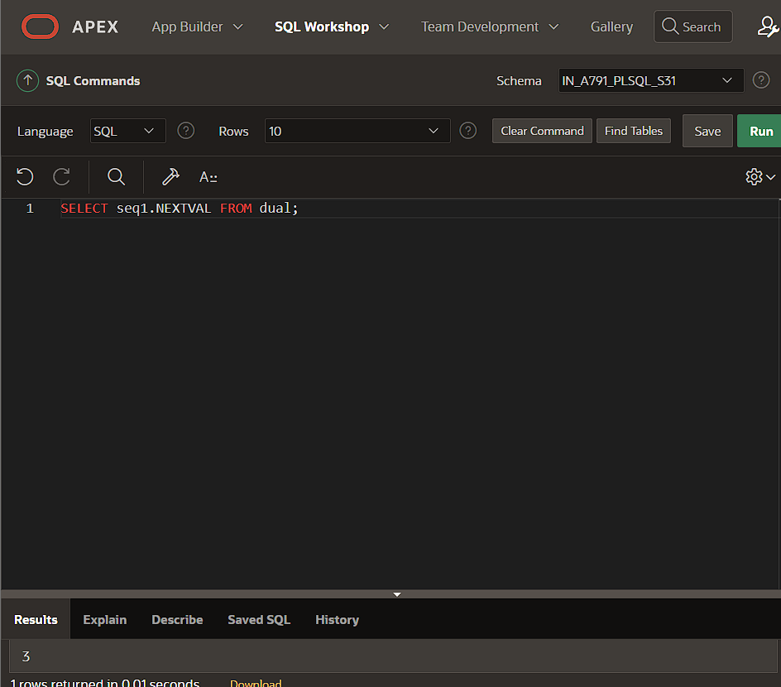

**IT START WITH 1 BECAUSE THE CYCLE AND CACHE ARE INVOLVED IN THE SYNTAX.**

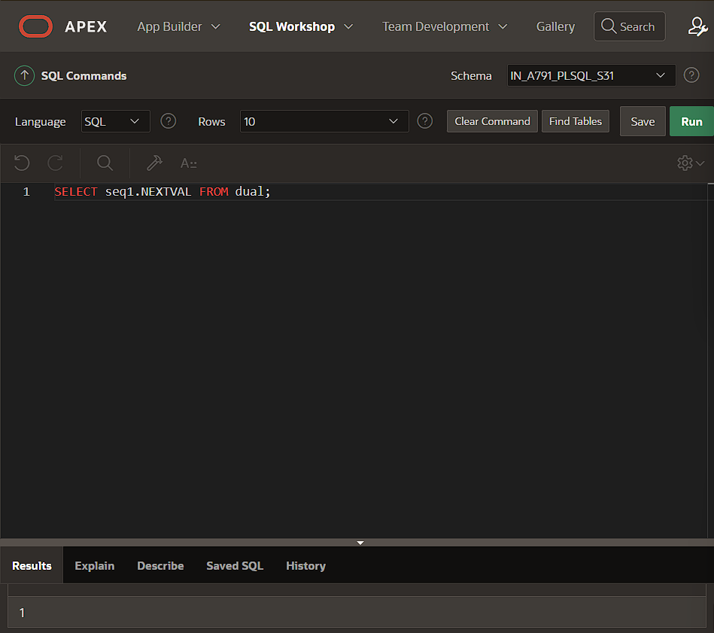

**SYNONYM**

select*from student ORDER BY STU_ID;

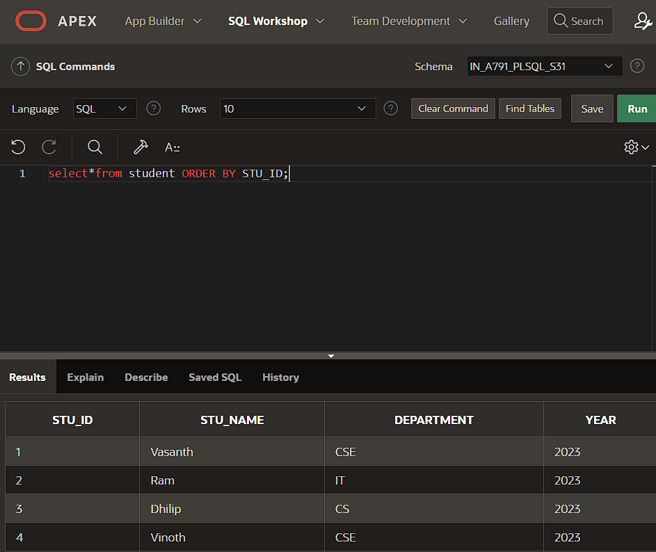

CREATE SYNONYM ST_DE FOR student;

select*from ST_DE;

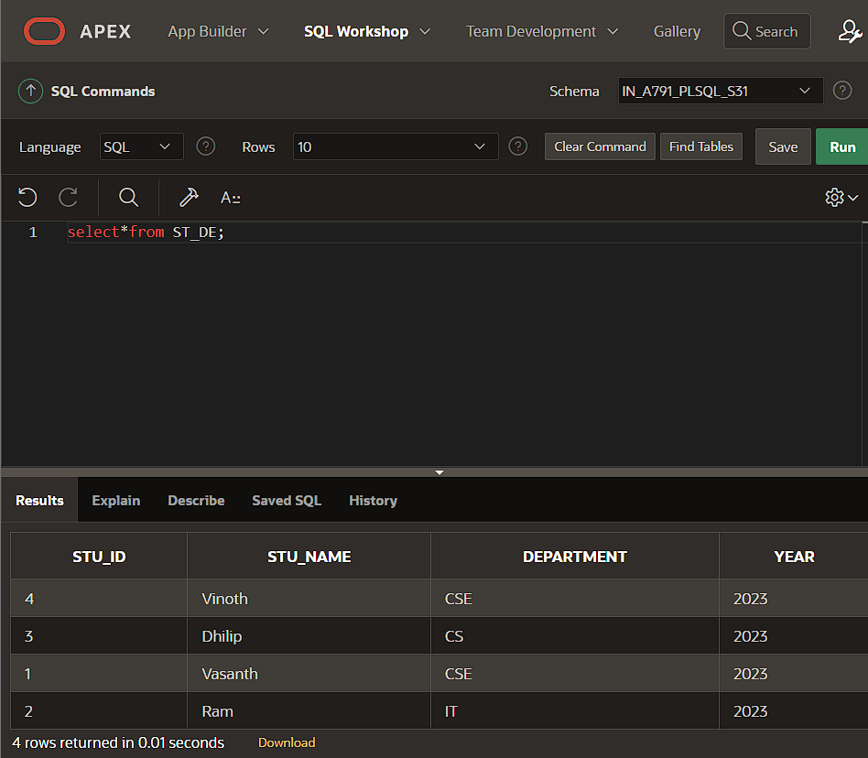

DROP SYNONYM ST_DE;